APPENDIX I
Standard Inter-connection diagram

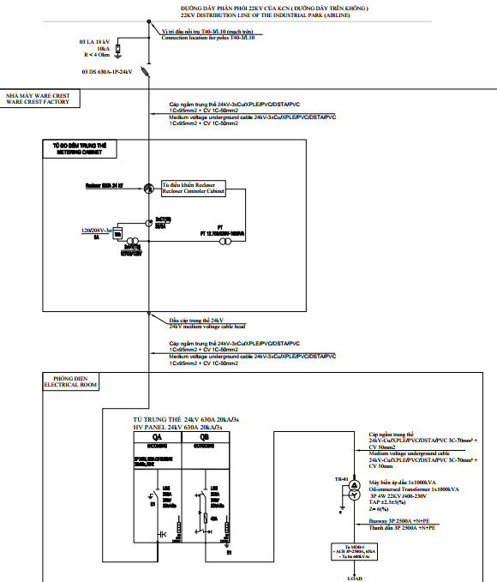

APPENDIX II

Applicable power selling prices
- The electricity selling price applied to the Buyer in Long Thanh High-Tech Industrial Park complies with Decision 2699/QĐ-BCT dated 11/10/2024 on electricity selling price and related legal documents;
- Costs for purchasing reactive power comply with Circular No. 15/2014/TT-BCT dated May 28, 2014 Regulations on buying and selling reactive power and related legal documents.
I. Determine retail price and related fees
- Power consumption Price:
  - The selling price of electricity for the group of manufactured products is calculated according to the latest prohibited electricity price list of the Copyright Authority.
  - Retail electricity prices for the manufacturing industry group according to reference at the time of making the contract appendix are as follows (VND/KWh):

No | Voltage level | Normal hours | Peak hours | Off-peak hours
1 | From 22 kV to under 110 kV | 1,749 | 3,242 | 1,136

- Reactive power purchase fee:

Reactive capacity purchase fee, which is the amount of money that the Buyer must pay to the Seller to offset additional costs arising from the Buyer's excessive use of reactive capacity, is calculated as follows:
T_{q} = T_{p} * k %
Therein:
- T_{q} : Payment for reactive power
- T_{p} : Payment for active energy
- k: Compensation coefficient for overuse of reactive power of the Buyer as prescribed;

Power factor  Cosφ | k (%) | Power factor  Cosφ | k (%)
≥ 0.9 | 0 | 0.74 | 21.62
0.89 | 1.12 | 0.73 | 23.29
0.88 | 2.27 | 0.72 | 25
0.87 | 3.45 | 0.71 | 26.76
0.86 | 4.65 | 0.7 | 28.57
0.85 | 5.88 | 0.69 | 30.43
0.84 | 7.14 | 0.68 | 32.35
0.83 | 8.43 | 0.67 | 34.33
0.82 | 9.76 | 0.66 | 36.36
0.81 | 11.11 | 0.65 | 38.46
0.8 | 12.5 | 0.64 | 40.63
0.79 | 13.92 | 0.63 | 42.86
0.78 | 15.38 | 0.62 | 45.16
0.77 | 16.88 | 0.61 | 47.54
0.76 | 18.42 | 0.6 | 50
0.75 | 20 | < 0.6 | 52.54

The coefficient k is determined according to cosφ (power coefficient) calculated as follows:
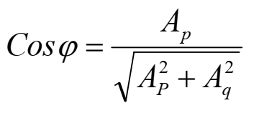
Therein:
- Ap: is the active electricity (consumed electricity) during the meter's reading cycle (kWh);
- Aq: is the reactive power received during the meter's reading cycle (kVArh);
- Demand charge Fee:
Demand charge: ……… VND/kVA/month;
- Service fee:
Service charge is as below:
Power Consumption  (kWh/month) | VND/kWh/  month | Discount  (%)
X < 500,000 | 34 | 0%
500,000 < X < 5,000,000 | 17 | 50%
5,000,000 < X | 0 | 100%

- Connection fee
At 01 (one) connection point, the Buyer have to pay a fixed fee of ………. VND (Thirty-six million VND).
All prices mentioned in this appendix and relevant documents are exclusive VAT

II.Regulations on power consumption time
Time of power consumption (Normal hour, Peak hour, Off-peak hour) are understood as below or in accordance with the latest applicable regulations, whichever is later.

- Normal hours:
- From Monday to Saturday:
- From 04 hrs 00 to 09 hrs 30 (05 hours and 30 minutes);
- From 11 hrs 30 to 17 hrs 00 (05 hours and 30 minutes);
- From 20 hrs 00 to 22 hrs 00 (02 hours).
- On Sunday:
- From 04 hrs 00 to 22 hrs 00 (18 hours)
- Peak hours:
- From Monday to Saturday:
- From 09 hrs 30 to 11 hrs 30 (02 hours);
- From 17 hrs 00 to 20 hrs 00 (03hours);
- On Sunday: Not applicable.
- Off-peak hours:
All days in a week: from 22 hrs 00 to 04 hrs 00 (06 hours).

APPENDIX III
Sample Calculation of the Power Charge
- The Applicable prices at 22 kV
For the calculation of the power charge, the following expressions are defined:
(i) Ap = Consumption Energy (kwh).
(ii) Tp = The Power Charge;
(iii) E = The power selling prices for 22 kV voltage level at the Delivery Point.
Example of Electricity Consumption Charge for 01 (one) month, use below as a model for calculation.
*The total capacity of the Buyer's transformer station is 1,000 kVA.
* Assume that the Buyer registers the largest registered capacity for 2025: 350 kW.
*The operating costs in the month are recorded as follows:
Read the meter results in 01 month of electricity use:
Active power (Ap) = 430,000 kWh
Reactive power (Aq) = 250,000 kVArh
Maximum power used in the month: 320 kW
In which Ap is recorded at:
Normal hours = 270,000 kWh
Peak hours = 90,000 kWh
Off-peak hours = 70,000 kWh

(A) Applicable selling power prices:
The Applicable unit prices (E) to be applied (at 22kV) at the time signing this Agreement are:
- 1,749 VND/kWh (Normal hours)
- 3,242 VND/kWh (Peak hours)
- 1,136 VND/kWh (Off-peak hours)
(B) Monthly Power Payment Calculation
(B.1) Active energy charge
Power Charge: Tp = Ap * E
= (270,000* 1,749) + (90,000* 3,242) + (70,000 * 1,136)

= 472,230,000 + 291,780,000 + 79,520,000 (VND)
Active energy charge payment before taxes: = 843,530,000 VND
(B.2) Reactive Energy Charge (the capacity of resistance)
The power factor is computed as following:

$\cos{φ}=\frac{430,000 }{\sqrt{{430,000 }^{2}+ {250,000}^{2}}}$ = 0.864 ≈ 0.86
With Cosϕ = 0.86 Adjusted factor k = 4.65 %.
Therefore, Reactive energy charge payment before taxes:
Tq = Tp* k % = 843,530,000 * 4.65% = 39,224,145 VND
(B.3) Management fee charge
- Demand charge (DC)
Because the maximum monthly usage is 320 kW < The registered capacity for 2025 is 350 kW, then:
Demand charge (DC) = 350 * 48,000
= 16,800,000 VND

- Servives Fee (SF)
Because the Power Consumption used in the month is 430,000 kWh < 500,000 kWh, the applicable unit price is 34 VND/kWh;
Servives Fee (SF) = 430,000 * 34
= 14,620,000 VND
- Management Fee (MF) = Demand charge (DC) + Service Fee (SF)
= 16,800,000 + 14,620,000
= 31,420,000 (VND)

Total Power Charge Payment before tax: = (B.1) + (B.2) + (B.3)
= 843,530,000 + 39,224,145 + 31,420,000
= 914,174,145 VND

APPENDIX IV
Contact List

STT |  | Seller | Buyer
1 | Technical, Operation | - Mr. Nguyen Dinh Tuan  - Mobile: 0907857462  - E Email: dinhtuan@amata.com | Mr.  Mobile:  Email:
2 | Payment, invoice | - Mr. Nguyen Minh Dang  - Mobile: 0385358221  Email: dang@amata.com | MS.  Mobile:  EEmail:

